THREE PHASE GRID CONNECTED

SOLAR PV INVERTER

SUMMARY:

Using the MPPT control, PLL, αβ0,abc,dq0 transformations a single state three phase grid connected solar PV inverter is constructed using Simulink.

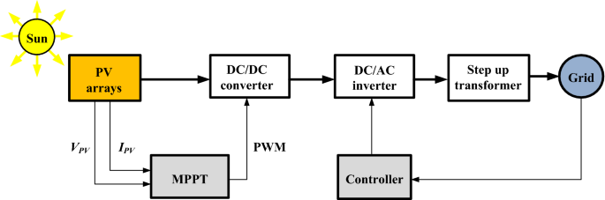

The PV array is connected to the DC/DC converter with MPPT controller to control the and maintain the Vmax. Then an inverter is placed to send the AC power to the grid. Thus the PV is interfaced to the utility grid to obtain a proper power flow control. An LCL filter is used between ac supply of the inverter and the grid to filter out the harmonic content.

For the controlling part, the various techniques used in this module are MPPT(Maximum Power Point Tracking), Grid Synchronisation, Reactive Power Compensation and output harmonic reductions. The αβ0, dq0 transformations are used to obtain the required PWM pulses that are to be fed to the IGBT switches in the inverter. The PLL(Phase Locked Loop) is used in this module to eliminate the ‘q’ component in the voltage and produce the desired ‘wt’. Thus , the overall aim of this simulation is to maintain the grid-voltage(Vg) and look at the variations of the grid-current according to the irradiance provided to the PV-array.

ABOUT EACH BLOCK IN THE MODULE:

* MPPT:

Initially any design of the PV-array is choosen in the Simulink.

Ex: I have choosen –

‘ Isofoton IS-210/32 ’

Its specifications:----

Grid Voltage: VLL = 400V, f=50Hz.

Inverter: fsw = 40kHz.

LCL Filter: L= 500µH, C=100µF

18 parallel and 25 series strings, Vmppt = (1200-1500)V.

Voc = 1477.5V

At 1Kw/m2 : P = 9.4\*104 W

V = 1197.5 V

At 0.5kW/m2 : P = 4.72\*104 W

V = 1195.4V

At 0.1kW/m2 : P = 1.94\*104 W

V = 1128.53V

The Voc voltage produced from the PV array is given to the 3-ᴓ Inverter. MPPT tracking is done to maintain the

V-pv = Vmax = 1400V.

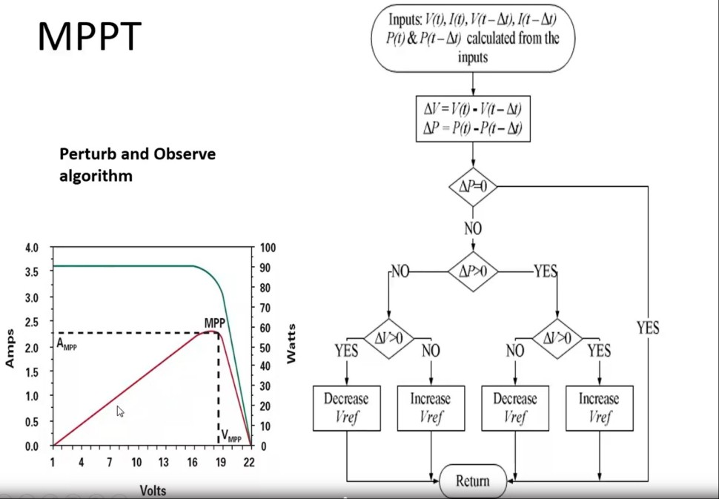

The perturb algorithm above explains the working of MPPT.

The Vref is adjusted by considering the ∆P = ∆V in the array.

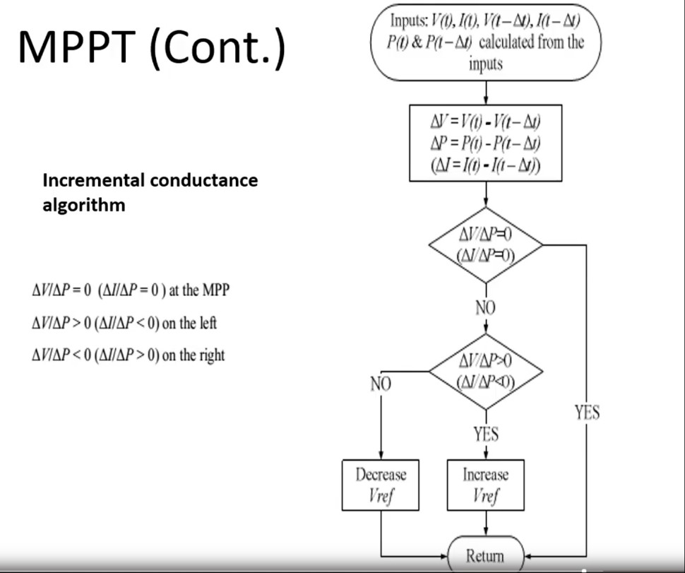

According to its values ∆P ≥ 0 or ∆V ≥ 0 , increase or decrease in the Vref value is done respectively.

Thus, the Vdref required is obtained.

* Design of Three Phase Inverter:

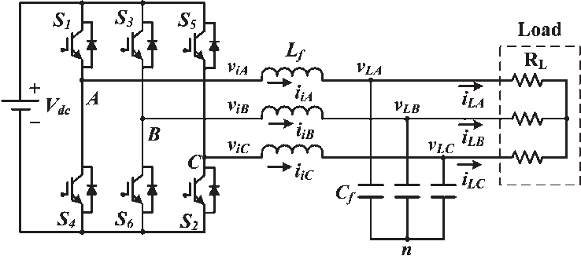

The three phase inveter is designed using six igbt switches with two switches in each leg and to obtain gate pulses to these switches, the pulses are given as control loop to the pwm.

Generally, the three arms of this inverter will be delayed with 120 degrees angle to generate a three phase AC supply.

The switches used in the inverter have 50% of ratio and switching can be occurred after every 60 degrees angle. The switches like S1, S2, S3, S4, S5, S6 will complement each other. In this, three inverters with single-phase are placed across a similar DC source. The pole voltages within the three phase inverter are equivalent to the pole voltages within the half-bridge inverter with a single phase.

* Inverter to filter to grid:

The obtained three phase inverted output are fed to the grid through the LCL filter. It eliminates the harmonics in the ia , ib , ic and converts it into Vabc and Iabc1.

This Vabc and Iabc1 are the final Vg and Ig produced at the grid side.

* Control Part:

Vabc to Vdq0 Transformation

The Vabc is transformed from abc/αβ0 block and again αβ0/dq0 block.

The Vd and Vq values are obtained.

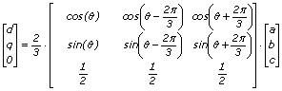

At θ = 0 , the transformation is done. The theoretical values of dq0 from abc is found by using the above equations.

But in Simulink we use abc/αβ0 and αβ0/dq0 two blocks for transformation. This is because the middle Vαβ0 and Iαβ0 values obtained are stored to use it for PLL design for obtaining the wt there.

* PLL:

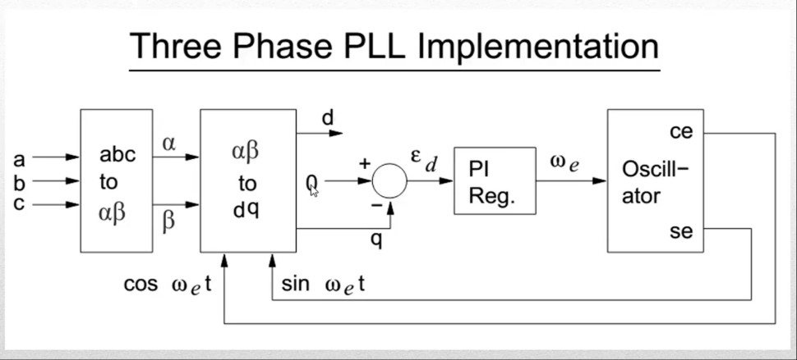

The three phase PLL produces Vd, Vq. It helps in making the

Vq = 0 as we need to align Vd with the grid voltage Vg. Thus, PLL helps in making Vq zero and sends the error produced to a PI regulator and produces the value of ‘ w ’. Integral function is placed later to produce ‘ wt ’ and the closed loop control of ‘ wt ’ is given to get the desired value.

* Producing Pulses:

The produced Vdref ,Vpv, Vd ,Id , Iq are all stored using ‘from’ block and ‘go’ block.

The Vdref and Vpv are compared and the error is fed to the PI-controller. The produced Idref is added to the feed forward path (2/3\*(Ppv/Vd)) and the resultant is compared to the Id obtained. The error is fed to the PI controller and the obtained output is then added to {((wLIq+Vd)\*2)/Vpv}. And the obtained value is fed to the d-part of the dq0 to abc transformation block.

In the similar way, Iq is compared to zero and fed through the PI-controller. The obtained output is added to {((Vq-wLId)\*2)/Vpv}. And the obtained is fed to the q-part of dq0 to abc transformation.

Thus, the obtained Vd and Vq are transformed to Vabc. The obtained Vabc reference is then compared with a repeating sequence and therefore, the positive pulses are fed to PWM1, PWM3, PWM5 and the negative pulses are fed to pwm2, pwm4, pwm6.

Thus the pulses given to the inverter are thus updated as the feed.

Altogether, the circuit obtained is:

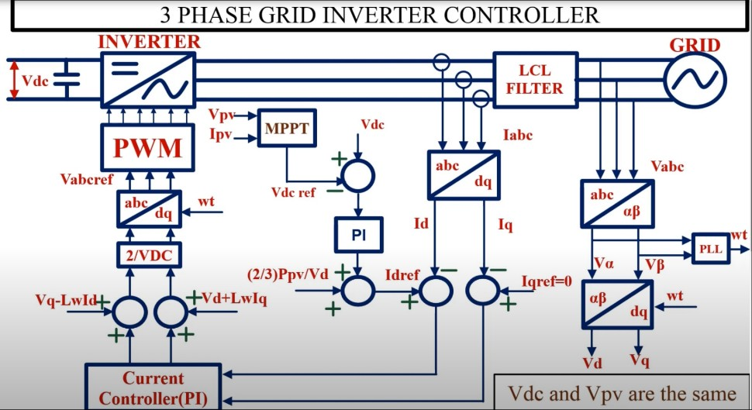

The Simulink circuit constructed is:

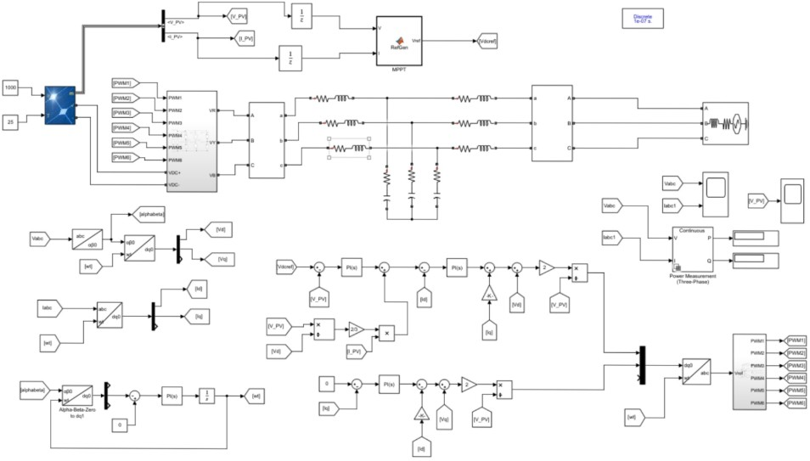

(For an enlarged view )



The data given in the Matlab code is:

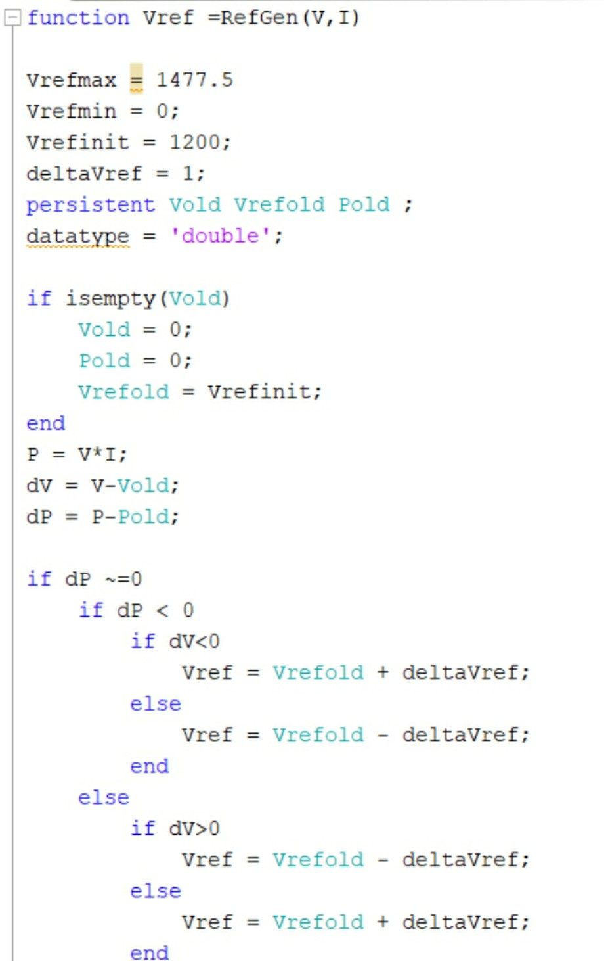

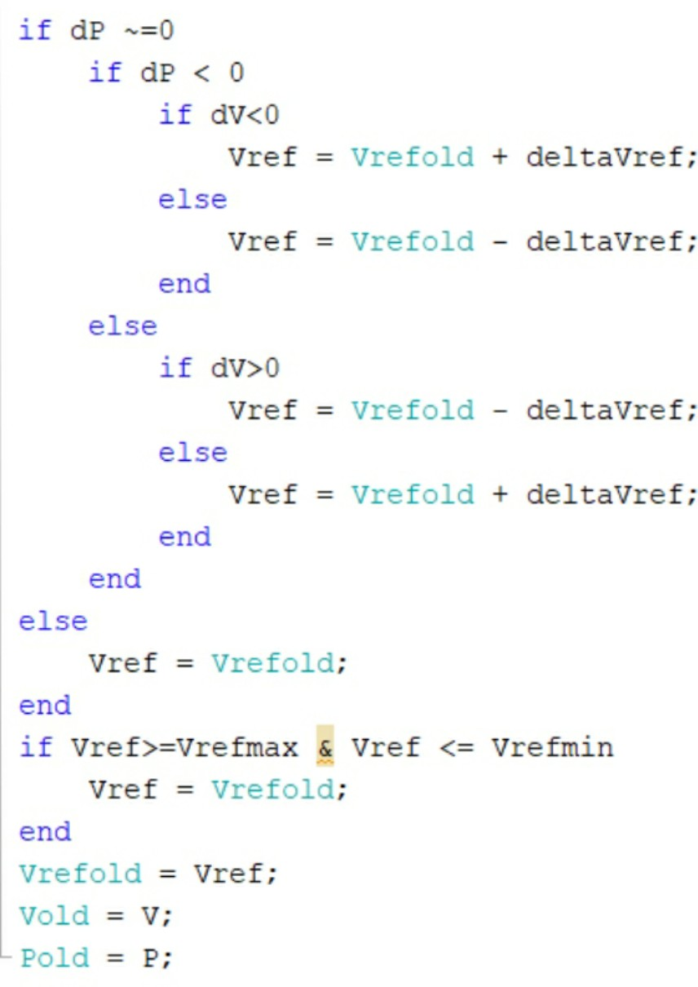

The three phase inverter circuit in Simulink:

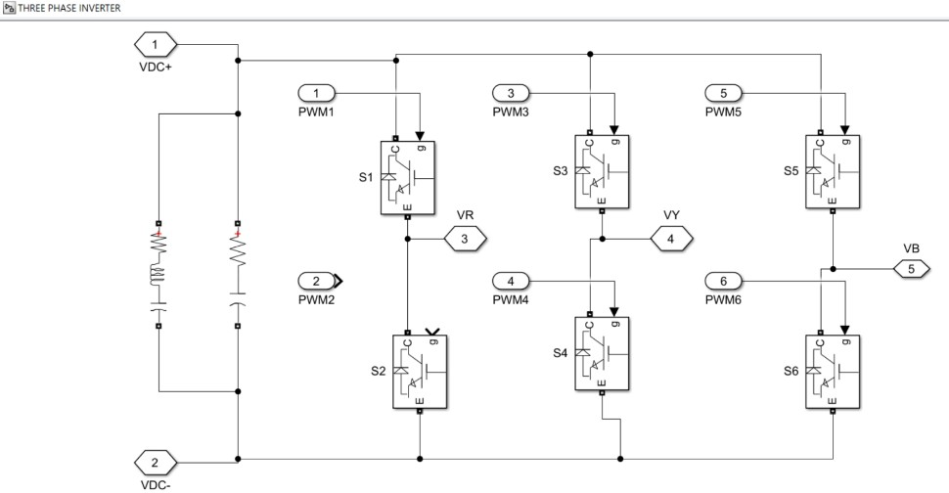

The Simulink circuit to give pulses to the PWM’s:

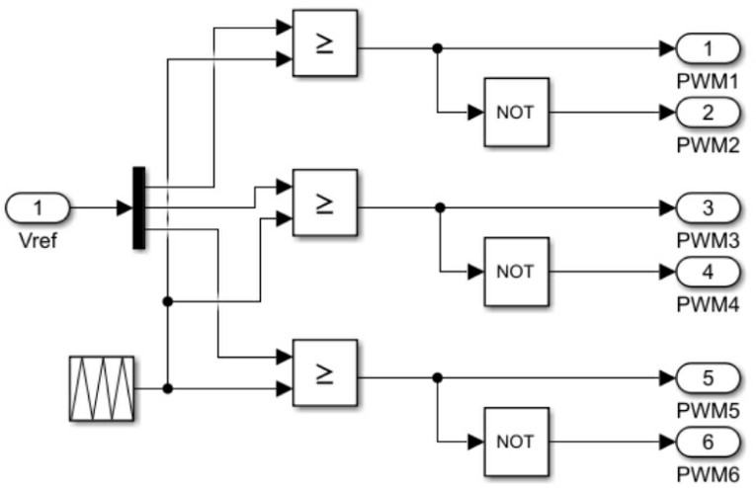

The obtained output waveforms are:

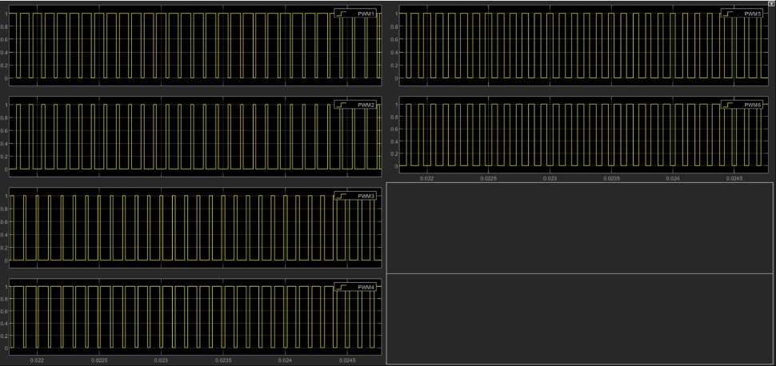

The supply voltage and the synchronized grid voltage(Vg) :

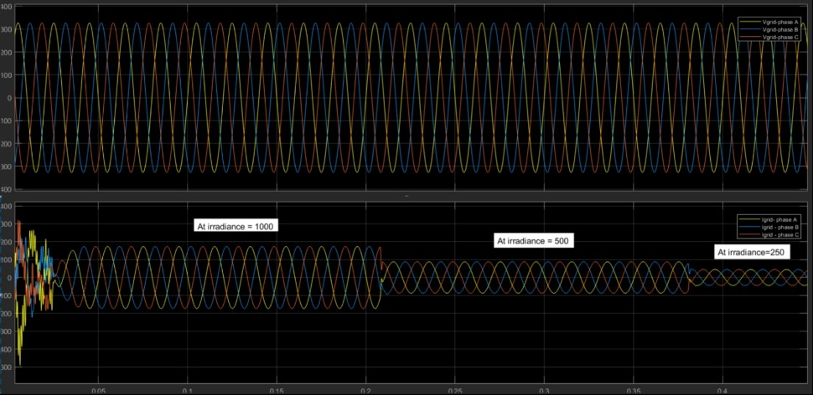

The MPPT plot control to maintain voltage at PV array is shown as:

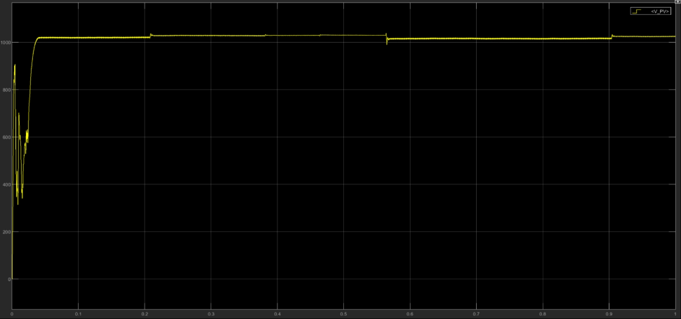

* Conclusion:

The above procedure is carefully followed and the simulation is done.

Thus, this design is done to observe Grid Voltage, Grid Current and PV array voltage.